|  |  |  |
| --- | --- | --- |
|  | CASE CONVERSION |  |
| Exp No.: 8 |  | **Name:** S Vishakan |
| Date: 14-10-2020 |  | **Reg. No:** 18 5001 196 |

**AIM:**

To write assembly language programs to perform alphabetical case conversion on the fly from standard input to standard output.

**PROGRAM - 1: CASE CONVERSION:**

**ALGORITHM:**

1. Begin.
2. Declare the data segment.
3. Initialize data segment with the count (number of input characters)
4. Close the data segment.
5. Declare the code segment.
6. Load the data segment content into AX register.
7. Transfer the contents of AX register to DS register.
8. Move the count into CX register.
9. Loop through count C1:
   1. Move 01h to AH, to input a character.
   2. Interrupt to get input.
   3. If input > 60
      1. Subtract the ASCII value by 20h.
   4. Else
      1. Add the ASCII value by 20h.
   5. Print the output through DOS’s standard output by moving it into DL register.
10. Introduce an interrupt for safe exit. (INT 21h)
11. Close the code segment.
12. End.

|  |  |
| --- | --- |
| **PROGRAM** | **COMMENTS** |
| assume cs:code, ds:data | Declare code and data segment. |
|  |  |
| data segment | Initialize data segment with values. |
| count equ 10h | Number of input characters to be taken. |
| data ends |  |
|  |  |
| code segment | Start the code segment. |
| org 0100h | Initialize an offset address. |
| start: mov ax, data | Transfer data from “data” to AX. |
| mov ds, ax | Transfer data from memory location AX to DS. |
| mov cx, count | Loads the value in count to CX register. |
| L1: mov ah, 1 | To input a character. |
| int 21h |  |
|  | ASCII (hex): A-Z= 41-5A, a-z= 61-7A. |
| cmp al, 60h | If AL > 60, then jump to ‘upper’. |
| jnc upper |  |
| add al, 20h | To convert the character to lowercase. |
| jmp skip |  |
|  |  |
| upper: sub al, 20h | To convert the character to uppercase. |
|  |  |
| skip: mov ah, 2 | To output a character. |
| mov dl,al | Transfers the contents in AL to DL to support printing. |
| int 21h |  |
| loop L1 | Loops till CX = 0. |
| mov ah, 4ch |  |
| int 21h | Interrupt the process with return code and exit. |
| code ends |  |
| end start |  |

**UNASSEMBLED CODE:**

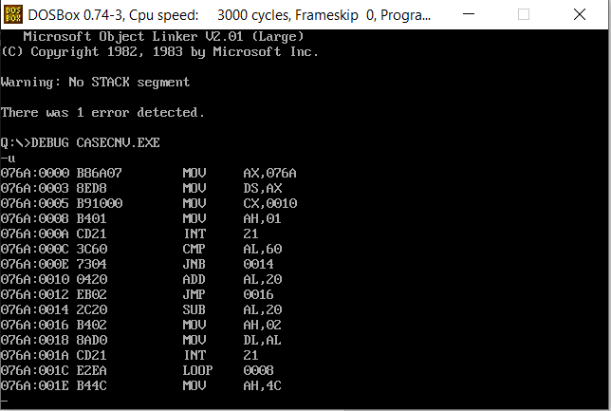

**SAMPLE I/O SNAPSHOT:**

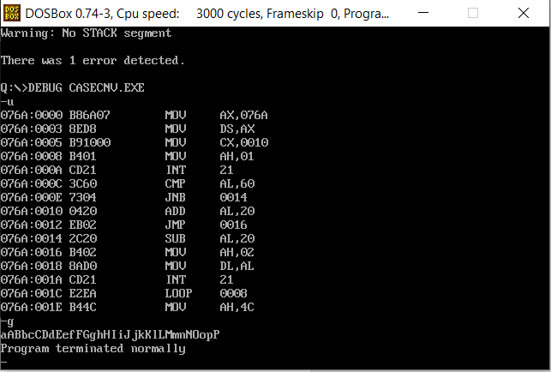

**RESULT:**

The assembly level program was written to perform the above specified case conversion and the output was verified.